 (For Unexempted /Exempted Establishments)

***Employee code _______________***

**(Mandatory)**

**FORM 2 (Revised)**

**NOMINATION AND DECLARATION FORM**

(Declaration and Nomination Form under the Employees’ Provident Funds and Employees’ Pension Scheme)

**(Paragraphs 33 & 61 (1) of the Employees’ Provident Funds Scheme, 1952 and paragraph 18 of the Employees’ Pension Scheme, 1995)**

|  |  |  |  |  |
| --- | --- | --- | --- | --- |
| **1** | **Name (in Block Letters)** | **:** |  | |
| **2** | **Father’s/Husband’s Name** | **:** |  | |
| **3** | **Date of birth** | **:** |  | |
| **4** | **Sex** | **:** |  | |
| **5** | **Marital Status** | **:** |  | |
| **6** | **Account No.** (PF/EPS Number) | **:** | **101192590663** | |
| **7** | **Address** (Residential) | **:** | **Permanent** |  |
|  |  |  | **Temporary** |  |

**PART A (EPF) #**

I hereby nominate the person(s)/cancel the nomination made by me previously and nominate, the person(s) mentioned below to receive the amount standing to my credit in the Employees’ Provident Fund, in the event of my death:

|  |  |  |  |  |
| --- | --- | --- | --- | --- |
| **Name and Address of the nominee/ nominees** | **Nominee’s relationship with the member** | **Date of Birth** | **Total amount or share of accumulations in Provident Fund to be paid to each nominee** **(%)** | **If the nominee is a minor, name and relationship and address of the guardian who may receive the amount during the minority of nominee** |
| **(1)** | **(2)** | **(3)** | **(4)** | **(5)** |
| **Sarat Kumar Moharana** | Father | 14-02-1965 | 45 |  |
| **Pranati Moharana** | Mother | 02-07-1969 | 45 |  |
| **Ipsita Maharana** | Sister | 13-09-1999 | 10 |  |
|  |  |  |  |  |
|  |  |  | **100%** |  |

**1 * Certified that I have no family as defined in para 2(g) of the Employees’ Provident Funds Scheme, 1952, and should I acquire a family hereafter, the above nomination should be deemed as cancelled.**

**2 * Certified that my father/mother is/are dependent upon me.**

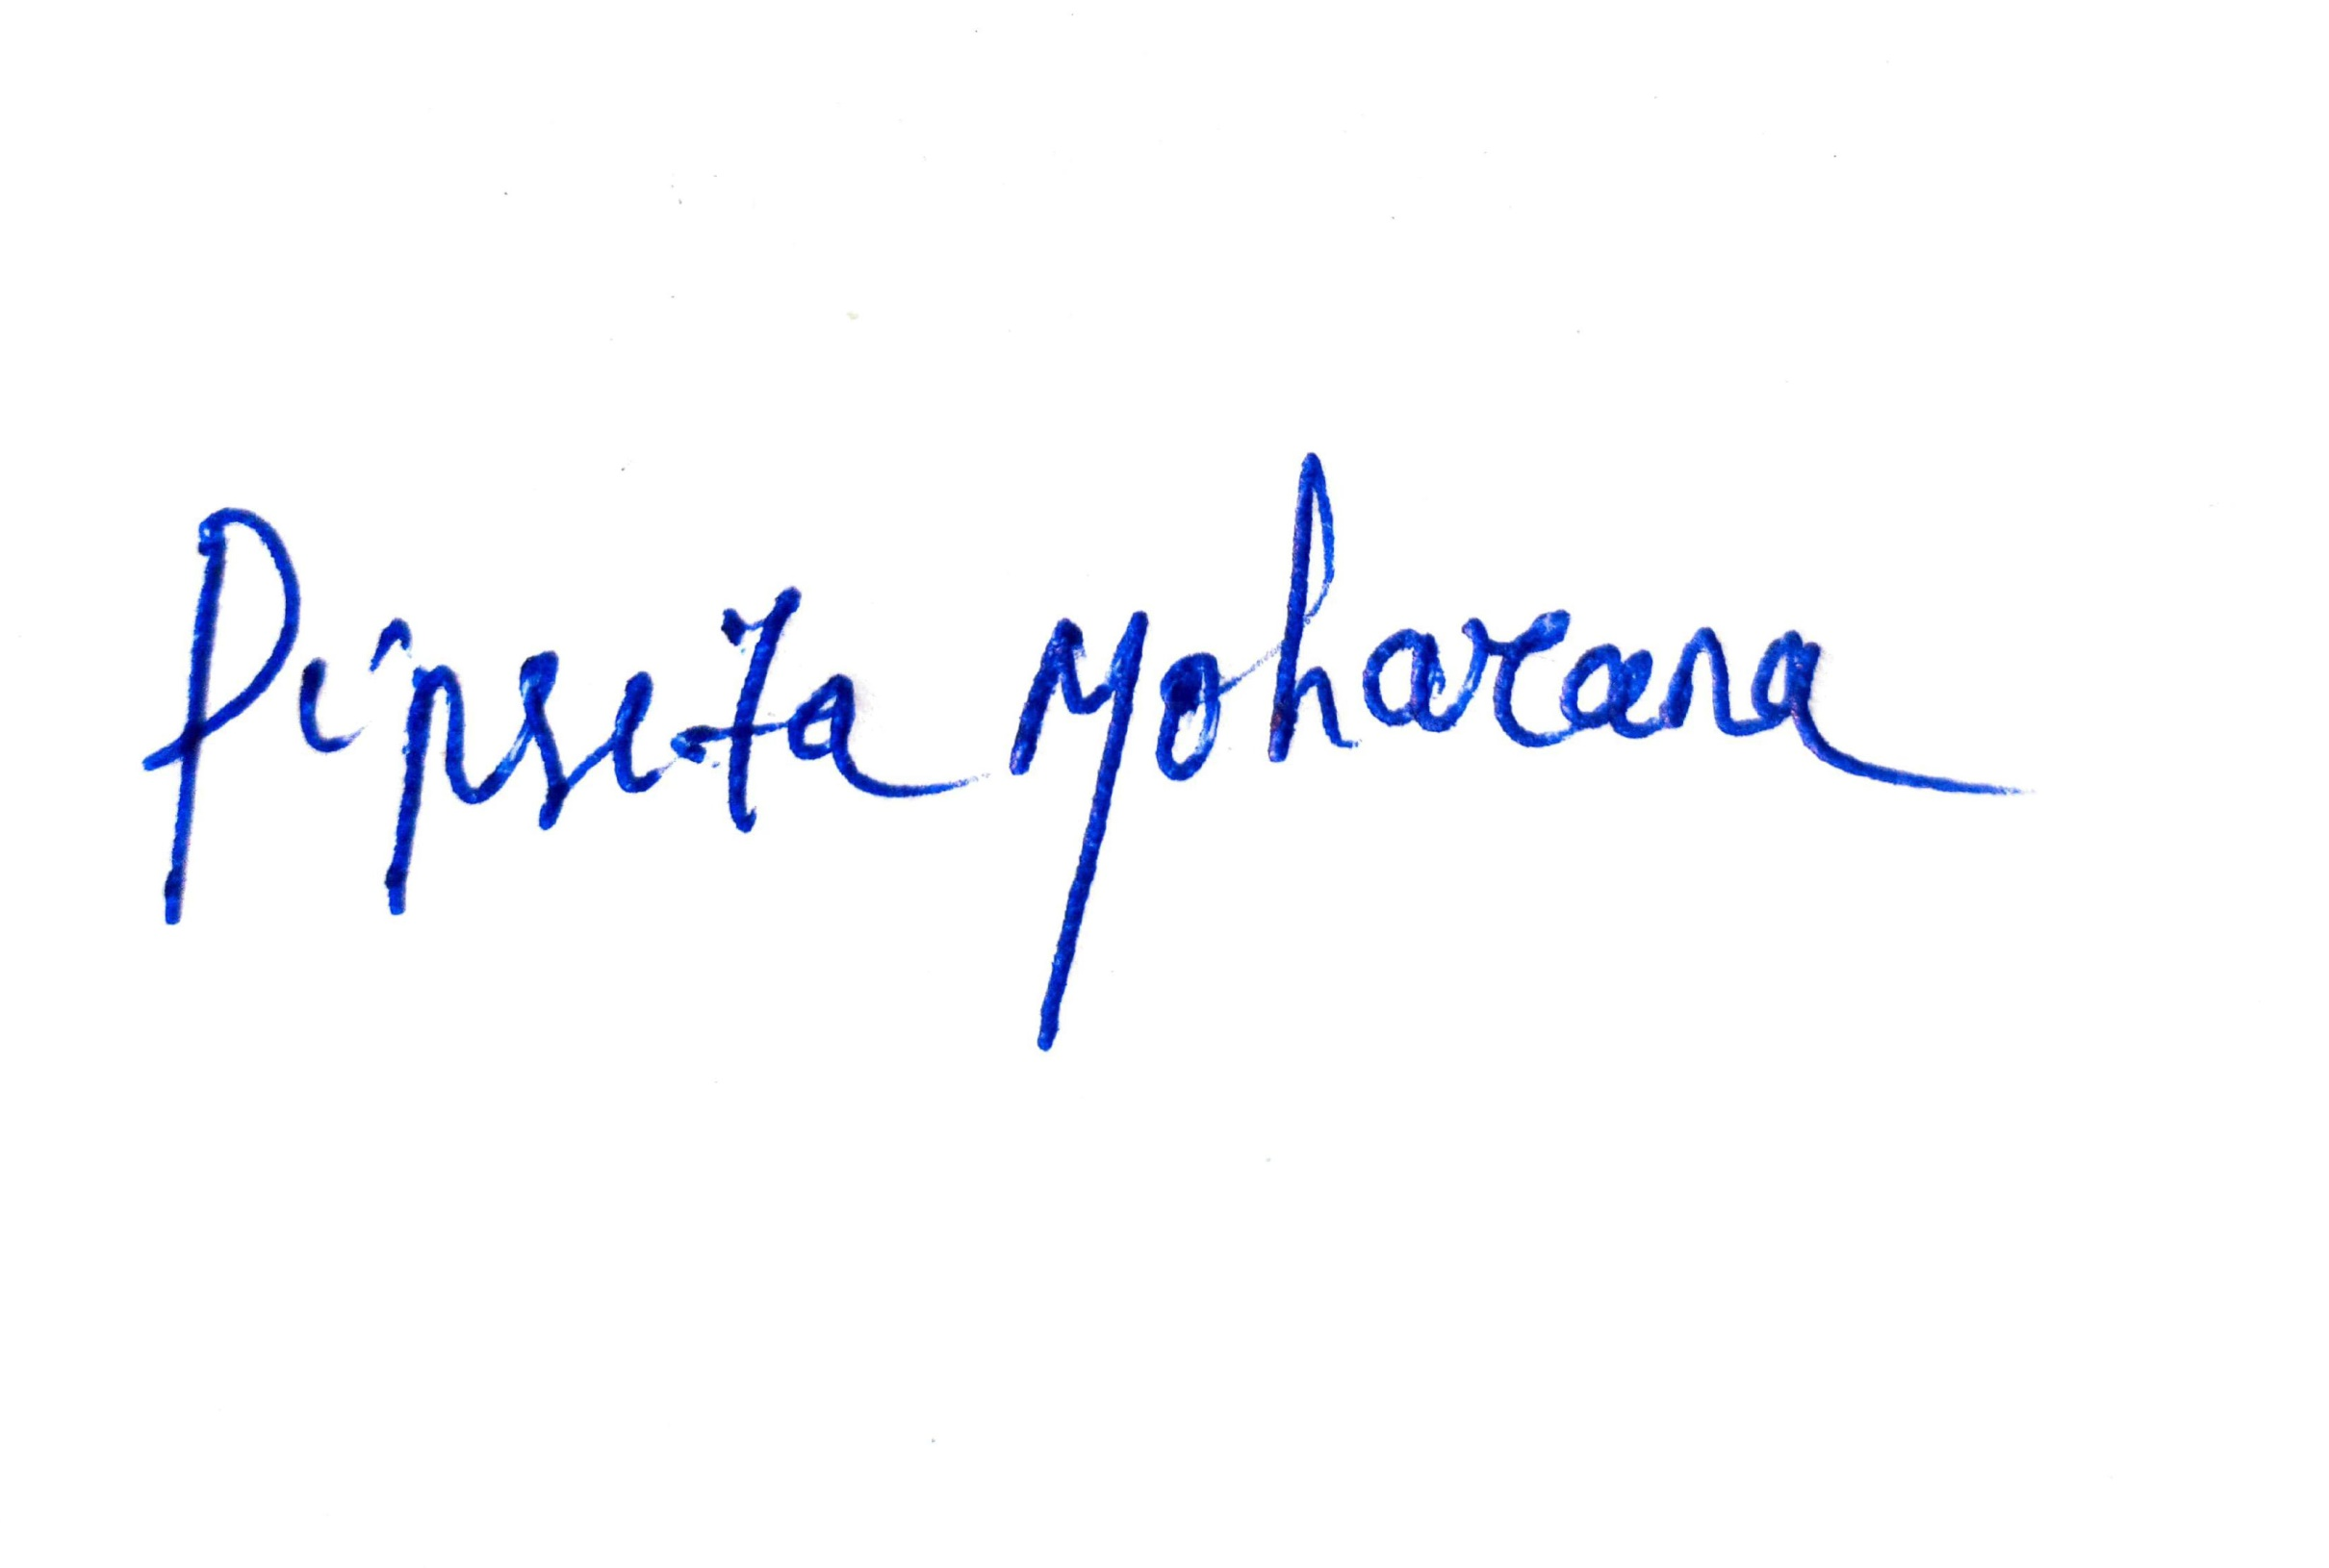

**3. * Strike out whichever is not applicable.**

**---------------------------------------------------------------------**

**Signature or thumb impression of the subscriber**

**Note: - A Fresh nomination shall be made by the member on his marriage and any nomination made before such marriage shall be deemed to be invalid**

# If Married –> Spouse, Children (married or unmarried), his/her dependent parents, deceased son’s widow and children.

If unmarried then Parents, Brother, Sister or any other person(s).

**Page No. – 1**

**Part B (EPS) (Para 18) $**

I hereby furnish below particulars of the members of my family who would be eligible to receive widow/children pension in the event of my death.

|  |  |  |  |
| --- | --- | --- | --- |
| **S.No.**  **(1)** | **Name and address of the family members**  **(2)** | **Date of Birth**  **(3)** | **Relationship with the member**  **(4)** |
| **1** | **Sarat Kumar Moharana, Badhei Sahi, Buxi Bazar, Cuttack** | 14-02-1965 | Father |
| **2** | **Pranati Moharana, Badhei Sahi, Buxi Bazar, Cuttack** | 02-07-1969 | Mother |
| **3** | **Ipsita Maharana, Badhei Sahi, Buxi Bazar, Cuttack** | 15-09-1999 | Sister |
| **4** |  |  |  |

** Certified that I have no family, as defined in para 2(vii) of Employees’ Pension Scheme, 1995 and should I acquire a family hereafter I shall furnish particulars thereon in the above form.

I hereby nominate the following persons for receiving the monthly widow pension (admissible under para 16 2(a) (i) and (ii) of Employees’ Pension Scheme, 1995 in the event of my death without leaving any eligible family member for receiving Pension. **$$**

|  |  |  |
| --- | --- | --- |
| **Name and Address of the Nominee**  **(1)** | **Date of Birth**  **(2)** | **Relationship with the member**  **(3)** |
| **Sarat Kumar Moharana, Badhei Sahi, Buxi Bazar, Cuttack** | 14-02-1965 | **Father** |
| **Pranati Moharana, Badhei Sahi, Buxi Bazar, Cuttack** | 02-07-1969 | **Mother** |
| **Ipsita Maharana, Badhei Sahi, Buxi Bazar, Cuttack** | 15-09-1999 | **Sister** |

28-12-2020



**Date : _____________________**

**………………………………………**

**Signature or thumb impression of the subscriber**

**\*\*Strike out whichever is not applicable.**

**CERTIFICATE BY EMPLOYER**

Certified that the above declaration and nomination has been signed/thumb impressed before me by Shri/Smt./Kumari________________________________________________________employed in my establishment after he/she has read the entries/the entries have been read over to him/her by me and got confirmed by him/her.

**Place: _________________**

**Date: __________________**

**………………………………………………………….**

**Signature of the Employer or other authorized**

**Officer of the establishment**

**Designation……………………………………….**

**Name and address of the Factory/Establishment**

**or rubber stamp thereof**

$ - Applicable if Married -> To Spouse and Children (include children adopted legally before death in service.

$$ - Applicable to both Married and unmarried – (1) Married - To any person(s) other than spouse and children.

(2) Unmarried - To Parents, Brother, Sister or any other person(s).

Instructions: Form has to be submitted on the day of Joining



Version 3.1

PAGE NO 1 OF 1

**GROUP MEDICAL POLICY AND PROVIDENT FUND DETAILS**

**PARTICULARS**

|  |  |  |  |  |
| --- | --- | --- | --- | --- |
| Name : Pipsita Moharana | | | | |
| Staff No: | Date of Joining: 28-12-2020 | Age: 23 | Level: F1 | Blood Grp: O+ve |
| PERSON TO BE NOTIFIED IN CASE OF EMERGENCY (Name & Phone No)  Sarat Kumar Moharana , 9861144052 | | | | |

Date of Birth (dd/mm/yyyy):

|  |
| --- |
| 10-05-1997 |

Are you a PF member:

|  |
| --- |
| Yes |

Dependent`s details (Only Spouse and Children):

|  |  |  |  |  |  |  |
| --- | --- | --- | --- | --- | --- | --- |
| Sr.No. | Name | Age  (Yrs) | Relation | Date of Birth | Blood Group | Gender |
|  |  |  |  |  |  |  |
|  |  |  |  |  |  |  |
|  |  |  |  |  |  |  |
|  |  |  |  |  |  |  |

**26-12-2020  
  
Employee Signature & Date**